**Table of Contents**

**A.** **API References** 2

**B.** **Logic Apps** 3

**I.** **Logic App – Pause and Resume** 3

**II.** **Logic App – Scale Compute** 22

**C.** **Azure Data Factory** 36

**I.** **ADF Managed Identity** 36

**II.** **ADF Pipeline – Pause and Resume** 39

**III.** **ADF Pipeline – Scale Compute** 48

**D.** **Fabric** 53

**I.** **Create a Service Principal** 53

**II.** **Fabric Pipeline – Pause and Resume** 58

**III.** **Fabric Pipeline – Scale Compute** 67

**E.** **Other Methods (not documented)** 72

**I.** **Azure Automation** 72

**II.** **Azure CLI** 72

**III.** **Azure Runbook** 72

**IV.** **PowerShell** 72

**F.** **References** 73

# **API References**

1. **Get** - GET [https://management.azure.com/subscriptions/{subscriptionId}/resourceGroups/{resourceGroupName}/providers/Microsoft.Fabric/capacities/{capacityName}?api-version=2023-11-01](https://management.azure.com/subscriptions/%7bsubscriptionId%7d/resourceGroups/%7bresourceGroupName%7d/providers/Microsoft.Fabric/capacities/%7bcapacityName%7d?api-version=2023-11-01)
2. **Suspend** - POST [https://management.azure.com/subscriptions/{subscriptionId}/resourceGroups/{resourceGroupName}/providers/Microsoft.Fabric/capacities/{capacityName}/suspend?api-version=2023-11-01](https://management.azure.com/subscriptions/%7bsubscriptionId%7d/resourceGroups/%7bresourceGroupName%7d/providers/Microsoft.Fabric/capacities/%7bcapacityName%7d/suspend?api-version=2023-11-01)
3. **Resume** - POST [https://management.azure.com/subscriptions/{subscriptionId}/resourceGroups/{resourceGroupName}/providers/Microsoft.Fabric/capacities/{capacityName}/resume?api-version=2023-11-01](https://management.azure.com/subscriptions/%7bsubscriptionId%7d/resourceGroups/%7bresourceGroupName%7d/providers/Microsoft.Fabric/capacities/%7bcapacityName%7d/resume?api-version=2023-11-01)
4. **Update** - PATCH [https://management.azure.com/subscriptions/{subscriptionId}/resourceGroups/{resourceGroupName}/providers/Microsoft.Fabric/capacities/{capacityName}?api-version=2023-11-01](https://management.azure.com/subscriptions/%7bsubscriptionId%7d/resourceGroups/%7bresourceGroupName%7d/providers/Microsoft.Fabric/capacities/%7bcapacityName%7d?api-version=2023-11-01)

# **Logic Apps**

## **Logic App – Pause and Resume**

*FYI: this Logic App looks at all compute under a single Resource Group and Resumes the Capacity during local time between 7:00 AM – and 4:00 PM and Pauses the Capacity outside of this time.*

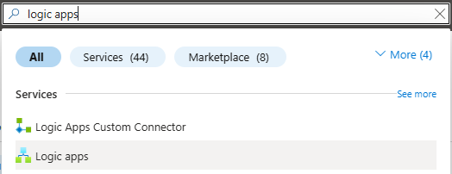

1. Type in **Logic Apps** in the search bar of the Azure Portal and select **Logic apps**

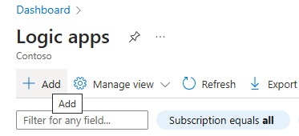

1. Click on **+ Add** to create the logic app

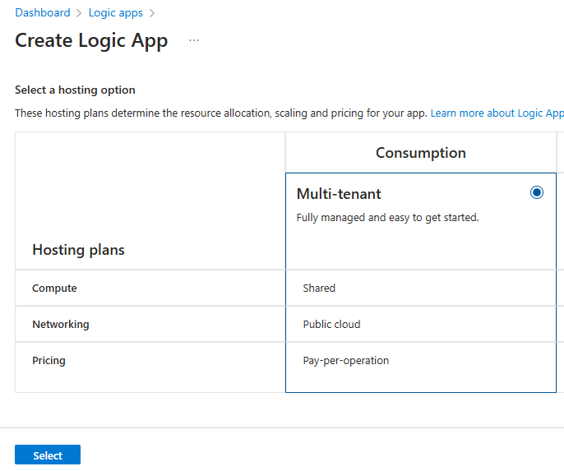

1. Select **Multi-tenant** and click the **Select** button

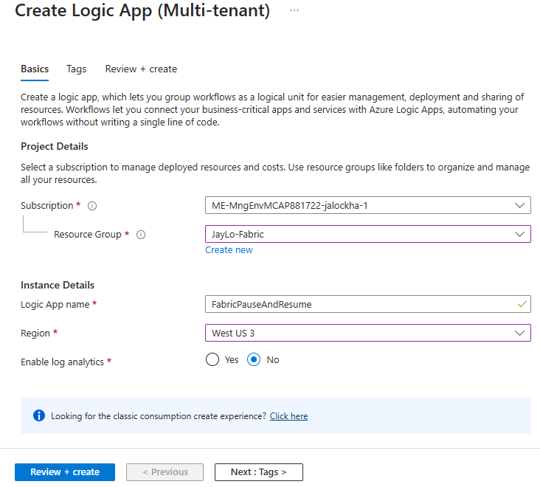

1. Select your **Subscription**
2. Select or Create a **Resource Group**
3. Enter the **Login App name**
4. Select a **Region**
5. Leave **Enable log analytics** as **No**
6. Click **Review + Create**

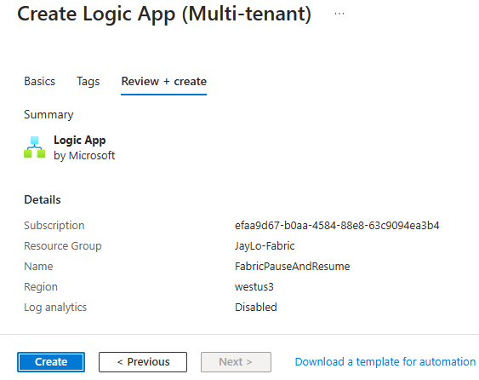

1. Review your selections, then click **Create**

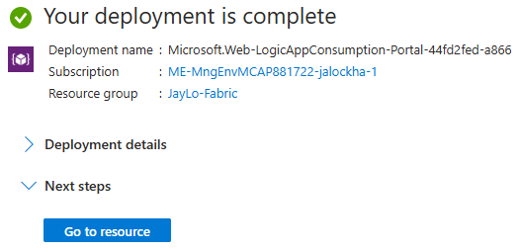

1. Once the Logic App is created, click on **Go to resource**

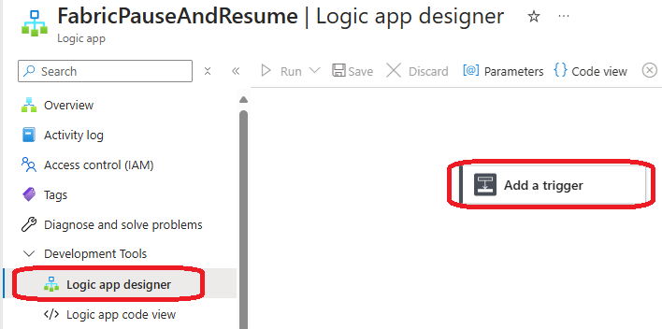

1. Click on **Logic app designer**
2. Click on **Add a trigger**

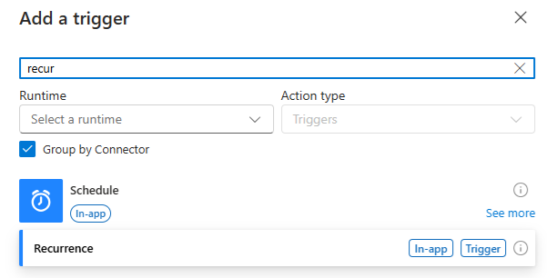

1. In the search bar type in **recur**, then select the **Recurrence** action

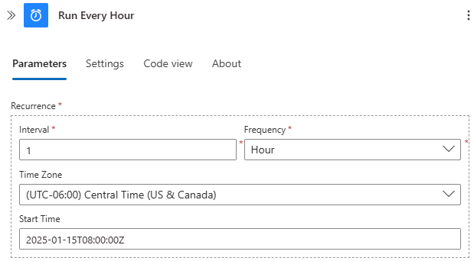

1. Change the name from **Recurrence** to **Run Every Hour**
2. Enter **1** for the **Interval**
3. Select **Hour** for the **Frequency**
4. Select your **Time Zone**
5. Enter a **Start Time** for the first run in this format: 2025-01-15T08:00:00Z

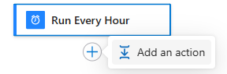

1. In the designer pane, click the **+** under **Run Every Hour** and select **Add an action**

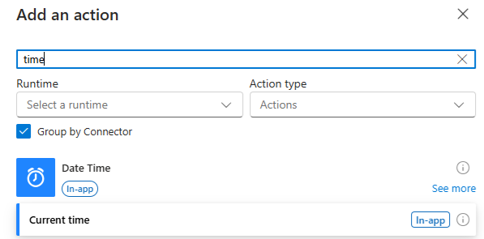

1. In the search bar type in **time**, then select the **Current time** action

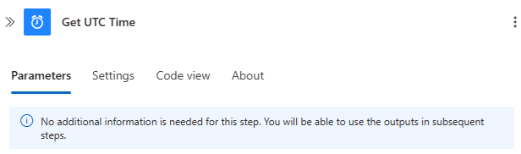

1. Change the name to **Get UTC Time**
2. In the designer pane, click the **+** under **Get UTC Time** and select **Add an action**

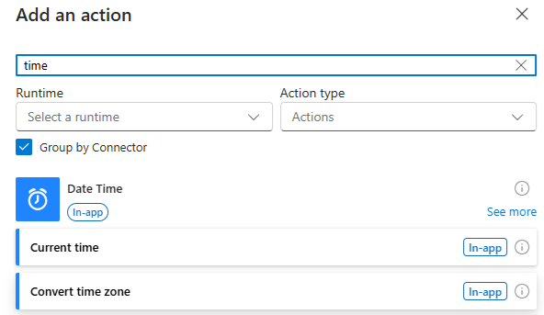

1. In the search bar type in **time**, then select the **Convert time zone** action

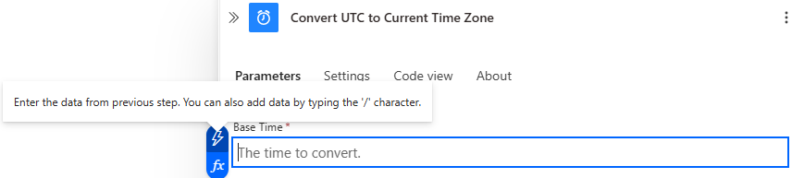

1. Change the name to **Convert UTC to Current Time Zone**
2. Click in the **Base Time** box and select the **Lightning Bolt**

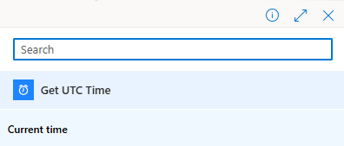

1. Select **Current time** underneath **Get UTC Time**

1. Select **(UTC) Coordinated Universal Time** for the **Source Time Zone**
2. Select **(UTC-06:00) Central Time (US & Canada)** for the **Destination Time Zone**
3. Enter **HH:mm** for the **Time Unit**
4. In the designer pane, click the **+** under **Convert UTC to Current Time Zone** and select **Add an action**

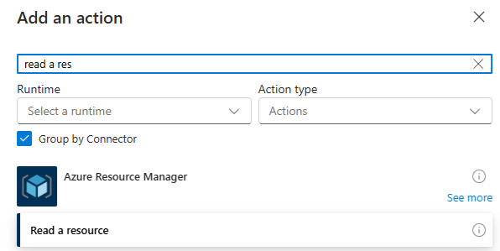

1. In the search bar type in **read a res**, then select the **Read a resource** action

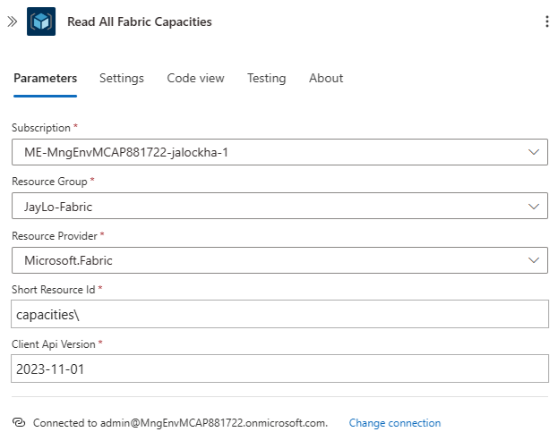

1. Change the name to **Read All Fabric Capacities**
2. Select your **Subscription**
3. Select your **Resource Group**
4. Select **Microsoft.Fabric** as the **Resource Provider**
5. Enter **capacities\** as the **Short Resource Id**
6. Enter **2023-11-01** as the **Client Api Version**
7. In the designer pane, click the **+** under **Read All Fabric Capacities** and select **Add an action**

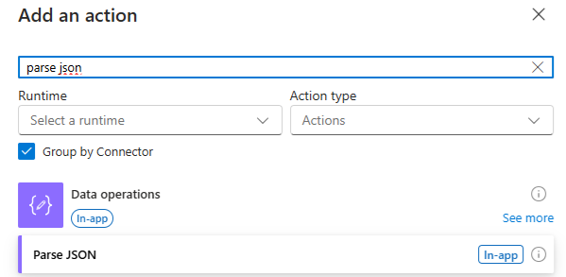

1. In the search bar type in **parse json**, then select the **Parse JSON** action

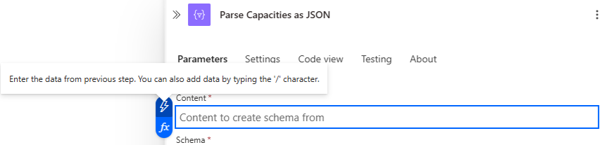

1. Change the name to **Parse Capacities as JSON**
2. Click in the **Content** box and select the **Lightning Bolt**

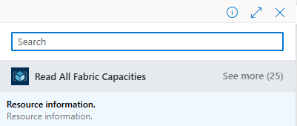

1. Select **Resource information** from the list
2. Paste the following JSON into the Schema box

{

    "type": "object",

    "properties": {

        "value": {

            "type": "array",

            "items": {

                "type": "object",

                "properties": {

                    "properties": {

                        "type": "object",

                        "properties": {

                            "provisioningState": {

                                "type": "string"

                            },

                            "state": {

                                "type": "string"

                            },

                            "administration": {

                                "type": "object",

                                "properties": {

                                    "members": {

                                        "type": "array",

                                        "items": {

                                            "type": "string"

                                        }

                                    }

                                }

                            }

                        }

                    },

                    "id": {

                        "type": "string"

                    },

                    "name": {

                        "type": "string"

                    },

                    "type": {

                        "type": "string"

                    },

                    "location": {

                        "type": "string"

                    },

                    "sku": {

                        "type": "object",

                        "properties": {

                            "name": {

                                "type": "string"

                            },

                            "tier": {

                                "type": "string"

                            }

                        }

                    },

                    "tags": {

                        "type": "object",

                        "properties": {}

                    }

                },

                "required": [

                    "properties",

                    "id",

                    "name",

                    "type",

                    "location",

                    "sku",

                    "tags"

                ]

            }

        }

    }

}

1. The Action should look like this
2. In the designer pane, click the **+** under **Parse Capacities as JSON** and select **Add an action**

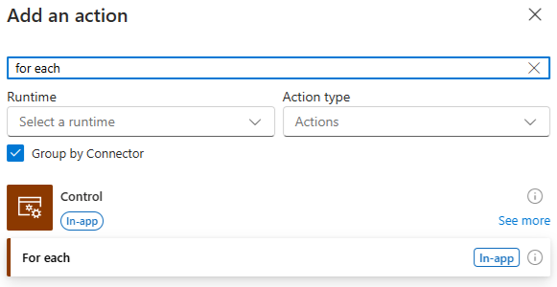

1. In the search bar type in **for each**, then select the **For each** action

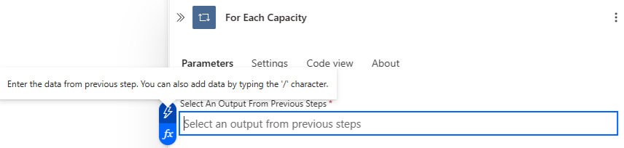

1. Change the name to **For Each Capacity**



1. Click in the **Select An Output From Previous Steps** box and select the **Lightning Bolt**

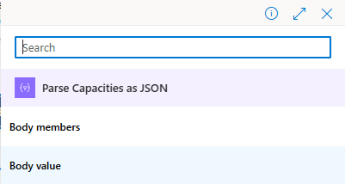

1. Select **Body value**

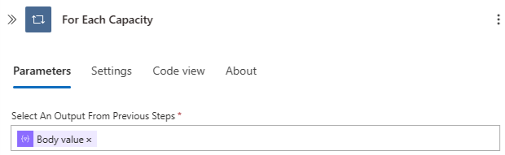

1. The Action should look like this
2. In the designer pane, click the **+** under **For Each Capacity** and select **Add an action**

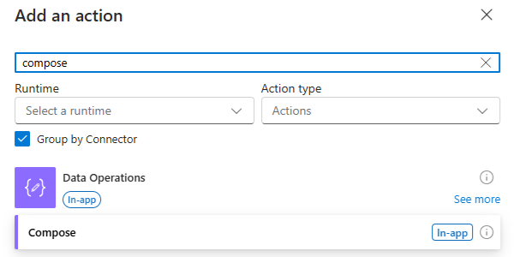

1. In the search bar type in **compose**, then select the **Compose** action

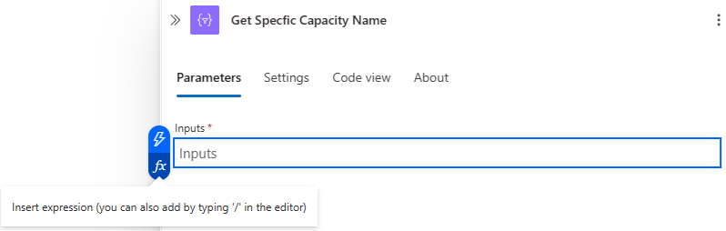

1. Change the name to **Get Specific Capacity Name**
2. Click in the **Inputs** box and select the **Fx**

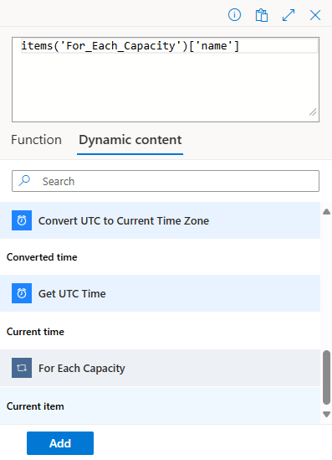

1. Click on **Dynamic content**, then click **Body** under **For Each Capacity**
2. Add **['name']** to the end of **body('For_Each_Capacity')**
3. Click **Add**

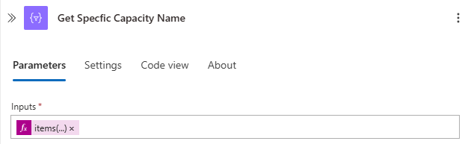

1. The Action should look like this
2. In the designer pane, click the **+** under **Get Specific Capacity Name** and select **Add an action**

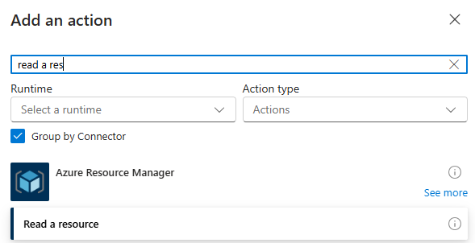

1. In the search bar type in **read a res**, then select the **Read a resource** action

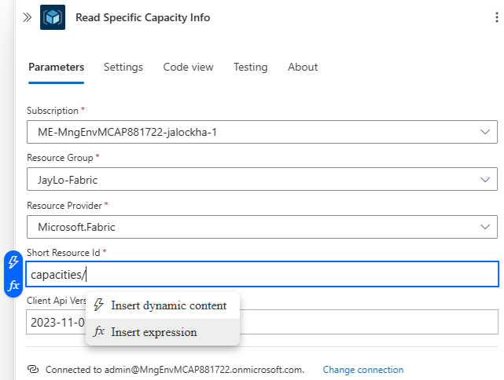

1. Change the name to **Read All Fabric Capacities**
2. Select your **Subscription**
3. Select your **Resource Group**
4. Select the **Microsoft.Fabric** as the **Resource Provider**
5. Enter **capacities/** as the **Short Resource Id**
6. Enter **2023-11-01** as the **Client Api Version**
7. Click on the **Short Resource Id** and place the cursor after the **/**, then click on **Insert dynamic content** or click on the **Lightning Bolt**

1. Select **Outputs** under **Get Specific Capacity Name**



*FYI: make sure the* ***/*** *is between capacities and Outputs*

1. The **Short Resource Id** should look like this
2. In the designer pane, click the **+** under **Read Specific Capacity Info** and select **Add an action**

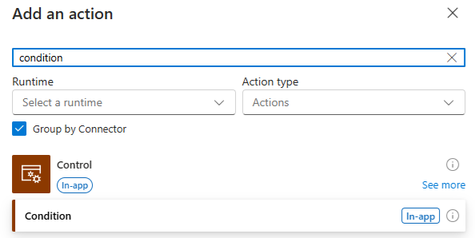

1. In the search bar type in **condition**, then select the **Condition** action

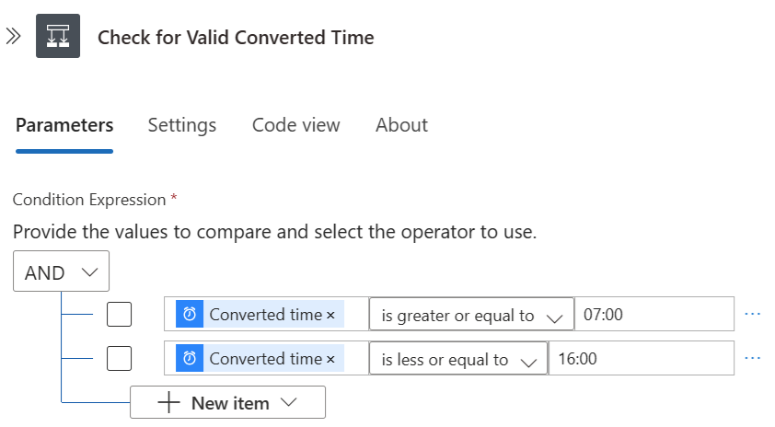

1. Change the name to **Check for Valid Converted Time**
2. Click the **Choose a value** box and select the **Lightning Bolt**
3. Select **Converted time** under the **Convert UTC to Current Time Zone**
4. Set the **is equal to** to **is greater or equal to**
5. Set the **Choose a value** to **07:00**
6. Click the **+ New Item**
7. Click the **Choose a value** box and select the **Lightning Bolt**
8. Select **Converted time** under the **Convert UTC to Current Time Zone**
9. Set the **is equal to** to **is less or equal to**
10. Set the **Choose a value** to **16:00**

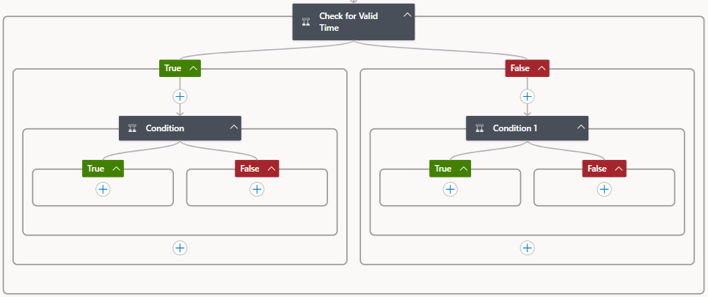

1. For both **True** and **False** under **the Check for Valid Converted Time**, click on the **+ Add an action** and select **Condition**

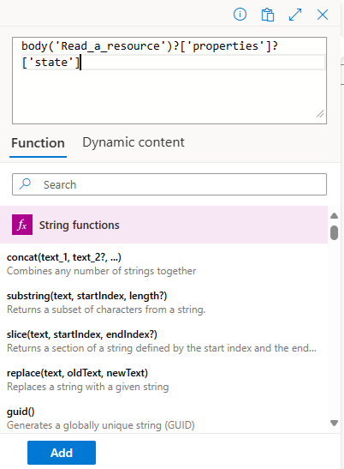

1. For the Condition under **True**, change the name to **Working Hours – ‘Is Paused’**, and then click on the **Fx** and enter **body('Read_Specific_Capacity_Info')?['properties']?['state']**
2. Click **Add**

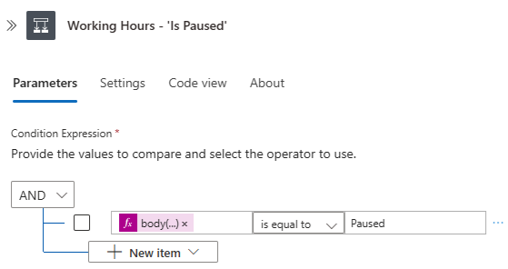

1. Should look like this

1. For the Condition under False, change the name to **After Hours - 'Is Paused'**, and then click on the **Fx** and enter **body('Read_Specific_Capacity_Info')?['properties']?['state']**
2. Click **Add**

1. Should look like this
2. Click on the **+** under **True** for the **Working Hours - ‘Is Paused’** and click **Add an action**

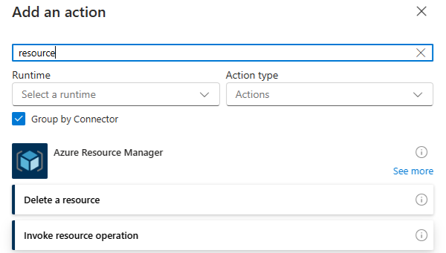

1. In the search bar type **resource** and select **Invoke resource operation**

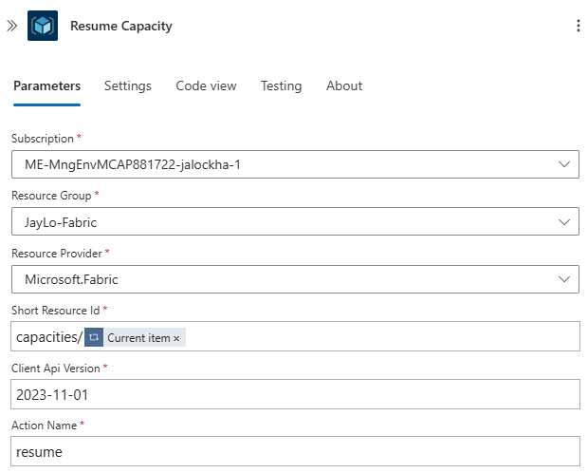

1. Change the **name** to **Resume Capacity**
2. Select your **Subscription**
3. Select your **Resource Group**
4. Select the **Microsoft.Fabric** as the **Resource Provider**
5. Enter **capacities/** as the **Short Resource Id,** then click on **Insert dynamic content** or click on the **Lightning Bolt** and select **Current item** under **For Each Capacity**

*FYI: make sure the* ***/*** *is between capacities and Outputs*

1. Enter **2023-11-01** as the **Client Api Version**
2. Enter **resume** for the **Action Name**
3. Click on the **+** under **False** for the **After Hours - ‘Is Paused’** and click **Add an action**

1. In the search bar type **resource** and select **Invoke resource operation**

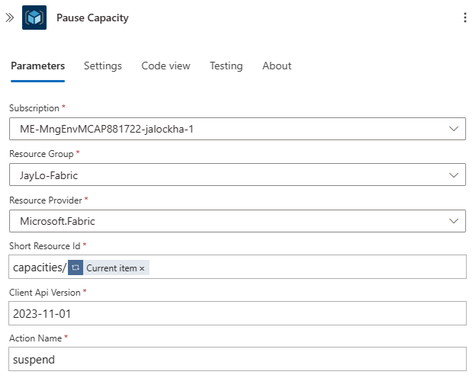

1. Change the **name** to **Pause Capacity**
2. Select your **Subscription**
3. Select your **Resource Group**
4. Select the **Microsoft.Fabric** as the **Resource Provider**
5. Enter **capacities/** as the **Short Resource Id,** then click on **Insert dynamic content** or click on the **Lightning Bolt** and select **Current item** under **For Each Capacity**

*FYI: make sure the* ***/*** *is between capacities and Outputs*

1. Enter **2023-11-01** as the **Client Api Version**
2. Enter **suspend** for the **Action Name**

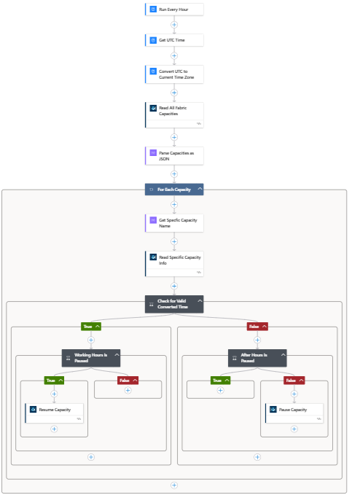

1. The whole flow should look like this
2. Click the **Save** button at the top
3. Click the **Run** button at the top and click **Run**

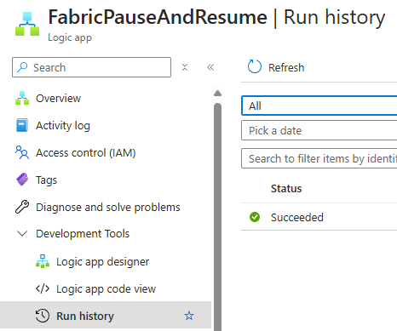

1. Click on **Run history** under **Development Tools**
2. You should see that your Logic App Succeeded

1. Click on the run to view the details

## **Logic App – Scale Compute**

*FYI: this Logic App uses a parameter consisting of an array of computes that are under a single Resource Group and Scales the Capacity Up during local time between 7:00 AM – and 11:00 AM and Scales the Capacity Down outside of this time.*

1. Click on **+ Add** to create a new the logic app

1. Select **Multi-tenant** and click the **Select** button

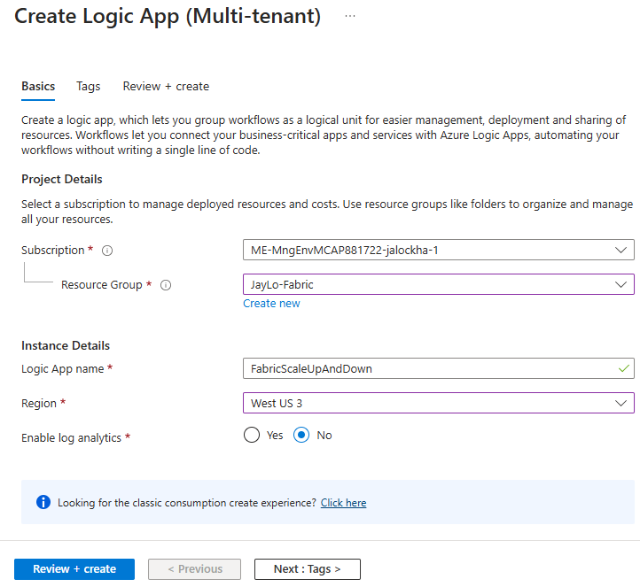

1. Select your **Subscription**
2. Select or Create a **Resource Group**
3. Enter the **Login App name**
4. Select a **Region**
5. Leave **Enable log analytics** as **No**
6. Click **Review + Create**

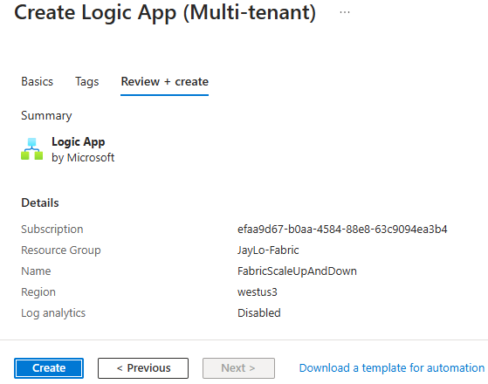

1. Review your selections, then click **Create**

1. Once the Logic App is created, click on **Go to resource**

1. Click on **Logic app designer**
2. Click on **Add a trigger**

1. In the search bar type in **recur**, then select the **Recurrence** action

1. Change the name from **Recurrence** to **Run Every Hour**
2. Enter **1** for the **Interval**
3. Select **Hour** for the **Frequency**
4. Select your **Time Zone**
5. Enter a **Start Time** for the first run in this format: 2025-01-15T08:00:00Z



1. In the top of the designer pane click **Parameters**
2. Click **+ Create parameters**

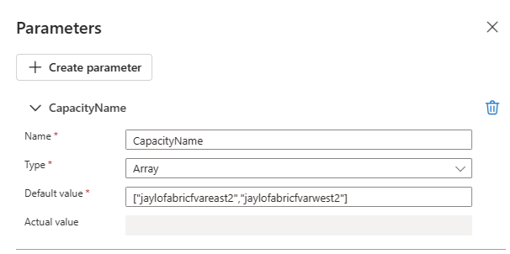

1. Enter **CapacityName** for the **Name**
2. Select **Array** for the **Type**
3. Enter a JSON string for the capacities that should be a part of the Scale operation

["jaylofabricfvareast2","jaylofabricfvarwest2"]

1. In the designer pane, click the **+** under **Run Every Hour** and select **Add an action**

1. In the search bar type in **time**, then select the **Current time** action

1. Change the name to **Get UTC Time**
2. In the designer pane, click the **+** under **Get UTC Time** and select **Add an action**

1. In the search bar type in **time**, then select the **Convert time zone** action

1. Change the name to **Convert UTC to Current Time Zone**
2. Click in the **Base Time** box and select the **Lightning Bolt**

1. Select **Current time** underneath **Get UTC Time**

1. Select **(UTC) Coordinated Universal Time** for the **Source Time Zone**
2. Select **(UTC-06:00) Central Time (US & Canada)** for the **Destination Time Zone**
3. Enter **HH:mm** for the **Time Unit**
4. In the designer pane, click the **+** under **Convert UTC to Current Time Zone** and select **Add an action**

1. In the search bar type in **for each**, then select the **For each** action

1. Change the name to **For Each Capacity**



1. Click in the **Select An Output From Previous Steps** box and select the **Lightning Bolt**

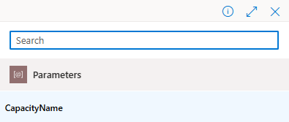

1. Select **CapacityName** under **Parameters**

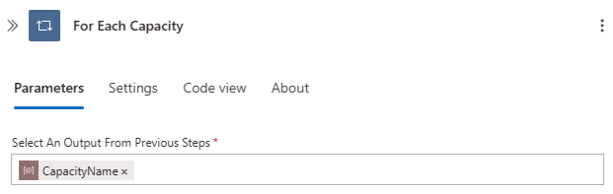

1. The Action should look like this
2. In the designer pane, click the **+** under **For Each Capacity** and select **Add an action**
3. In the search bar type in **read a res**, then select the **Read a resource** action

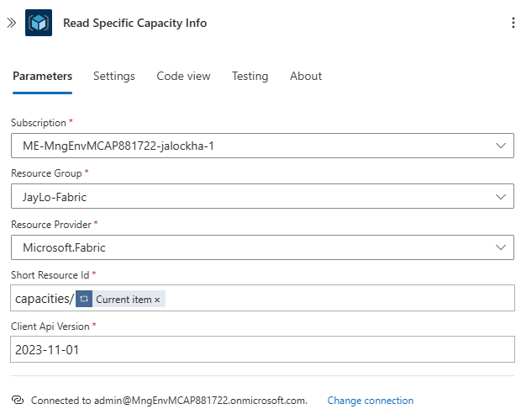

1. Change the name to **Read Specific Capacity Info**
2. Select your **Subscription**
3. Select your **Resource Group**
4. Select **Microsoft.Fabric** as the **Resource Provider**
5. Enter **capacities\** as the **Short Resource Id**, then click the **Lightning Bolt** and select **Current Item** under **For Each Capacity**
6. Enter **2023-11-01** as the **Client Api Version**
7. In the designer pane, click the **+** under **Read Specific Capacity Info** and select **Add an action**

1. In the search bar type in **condition**, then select the **Condition** action
2. Change the name to **If Paused**
3. Click the **Choose a value** box and select the **Fx**

1. Select **Dynamic content** and click the **Resource information** under **Read Specific Capacity Info**
2. Add **?['properties']?['state']** after the **body('Read_Specific_Capacity_Info')**
3. Click **Add**

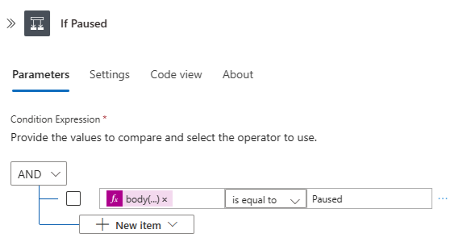

1. Click on **Choose a value** and enter **Paused**
2. Under **If Paused**, leave the **True** side as is with no actions
3. Under the **False** side, click the **+** under **False** and select **Add an action**

1. In the search bar type in **condition**, then select the **Condition** action

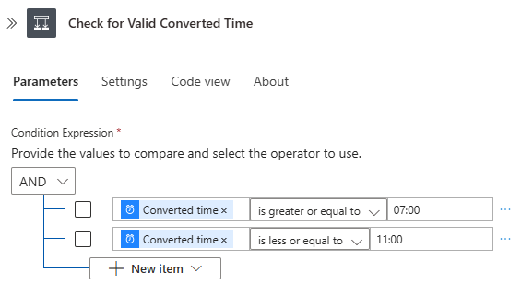

1. Change the name to **Check for Valid Converted Time**
2. Click the **Choose a value** box and select the **Lightning Bolt**
3. Select **Converted time** under the **Convert UTC to Current Time Zone**
4. Set the **is equal to** to **is greater or equal to**
5. Set the **Choose a value** to **07:00**
6. Click the **+ New Item**
7. Click the **Choose a value** box and select the **Lightning Bolt**
8. Select **Converted time** under the **Convert UTC to Current Time Zone**
9. Set the **is equal to** to **is less or equal to**
10. Set the **Choose a value** to **11:00**

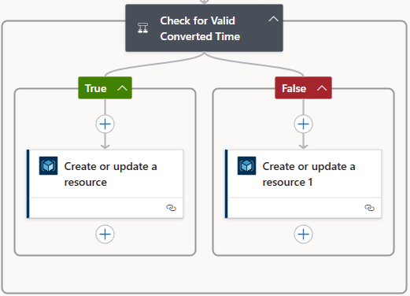

1. Under **Check for Valid Converted Time**, add an **Create or Update a resource** to both the **True** and **False** actions
2. Click on the **Create or Update a resource** under **True**

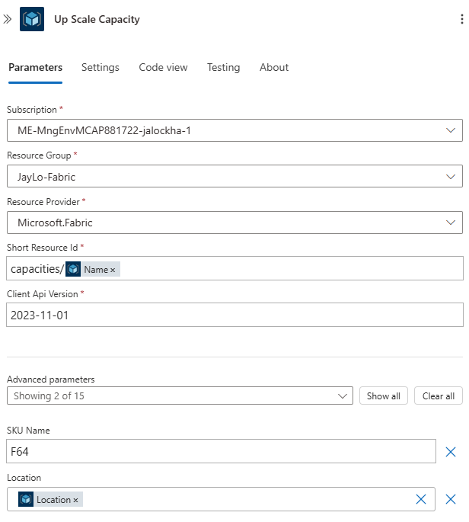

1. Change the **Name** to **Up Scale Capacity**
2. Select your **Subscription**
3. Select your **Resource Group**
4. Select **Microsoft.Fabric** as the **Resource Provider**
5. Enter **capacities\** as the **Short Resource Id**, then click the **Lightning Bolt** and select **Name** under **Read Specific Capacity Info**
6. Enter **2023-11-01** as the **Client Api Version**
7. Click on the **Advanced parameters** dropdown and select **SKU Name** and **Location**
8. Enter **F64** for the **SKU Name**

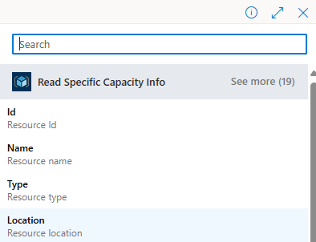

1. Select **Location** under **Read Specific Capacity Info**
2. Click on the **Create or Update a resource** under **False**

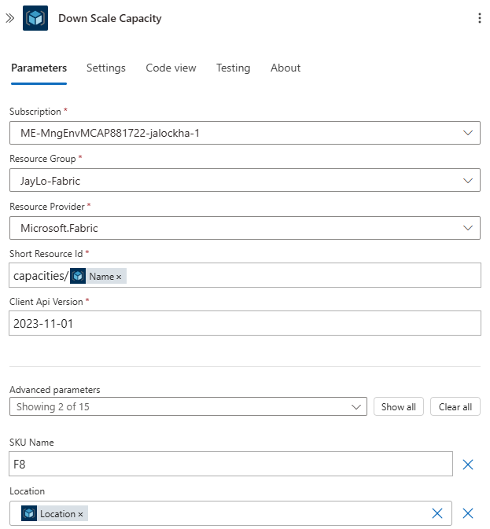

1. Change the **Name** to **Down Scale Capacity**
2. Select your **Subscription**
3. Select your **Resource Group**
4. Select **Microsoft.Fabric** as the **Resource Provider**
5. Enter **capacities\** as the **Short Resource Id**, then click the **Lightning Bolt** and select **Name** under **Read Specific Capacity Info**
6. Enter **2023-11-01** as the **Client Api Version**
7. Click on the **Advanced parameters** dropdown and select **SKU Name** and **Location**
8. Enter **F8** for the **SKU Name**

1. Select **Location** under **Read Specific Capacity Info**

1. The whole flow should look like this
2. Click the **Save** button at the top
3. Click the **Run** button at the top and click **Run**

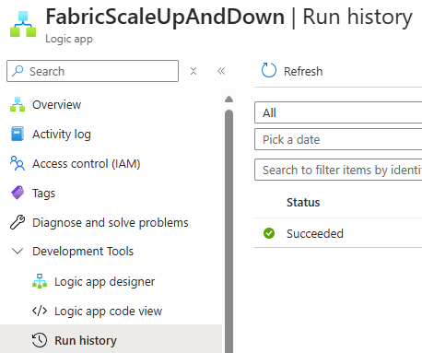

1. Click on **Run history** under **Development Tools**
2. You should see that your Logic App Succeeded

1. Click on the run to view the details

# **Azure Data Factory**

## **ADF Managed Identity**

1. In the Azure Portal, go to your Microsoft Fabric Compute

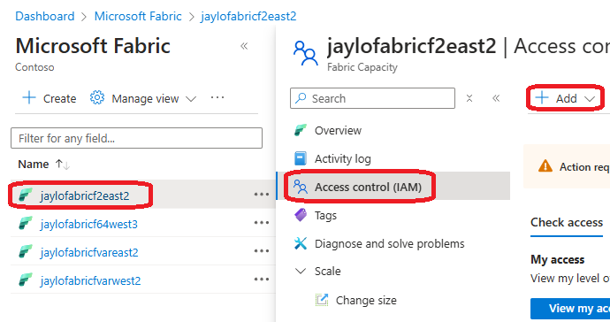

1. In the Azure Portal select one of your Fabric Capacities
2. Click on **Access Control (IAM)**
3. Click **+ Add**, then **Add role assignment**

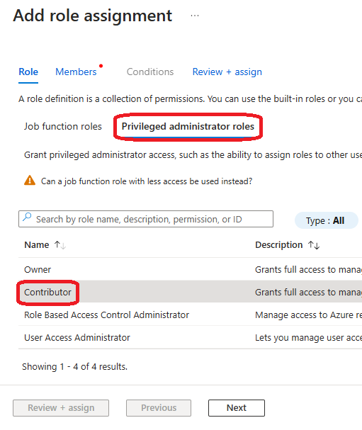

1. Click on **Privileged administrator roles**
2. Click **Contributor**
3. Click **Next**

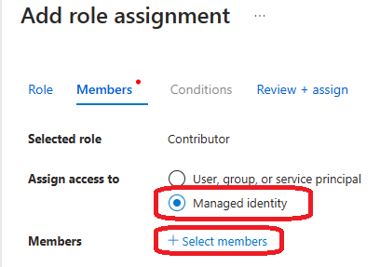

1. Select **Managed identity** then **+ Select Members**

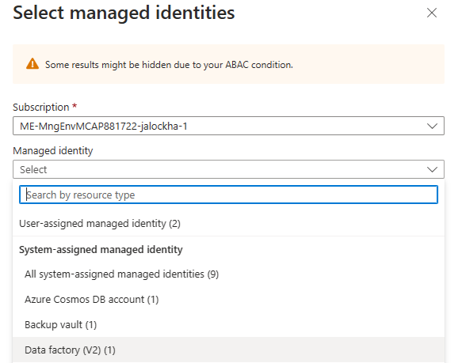

1. Select your **Subscription**
2. Under **Managed identity** select **Data factory (V2)**

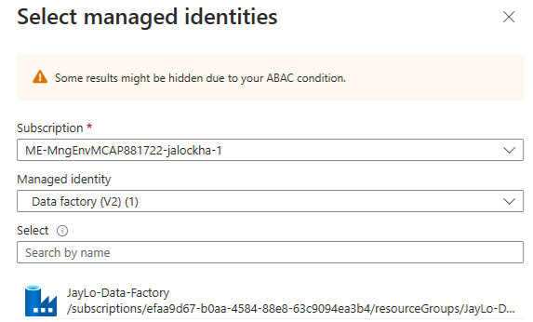

1. Click on your Data Factory Managed Identity to select it



1. Click **Select**



1. Click **Review + assign** twice
2. Repeat for all other capacities

## **ADF Pipeline – Pause and Resume**

1. Open **Azure Data Factory (ADF)**

1. Click on the **Pencil**
2. Click the **+** and select **Pipeline**

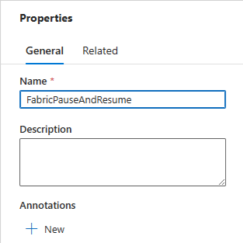

1. Name the Pipeline **FabricPauseAndResume**
2. Right-click anywhere in the canvas

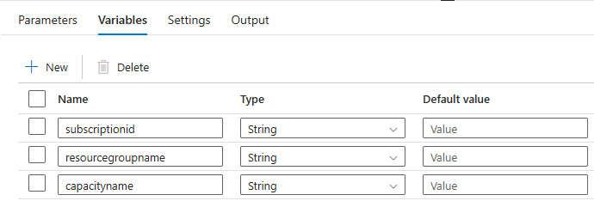

1. Click on the **Variables** tab and click **+ New** three times
2. Enter the name of the first variable as **subscriptionid**
3. Copy and paste the **Subscription ID** from the Azure Portal to the **Default value**
4. Enter the name of the second variable as **resourcegroupname**
5. Copy and paste the **Resource Group Name** from the Azure Portal to the **Default value**
6. Enter the name of the third variable as **capacityname**
7. Copy and paste the **Fabric** **Capacity Name** from the Azure Portal to the **Default value**

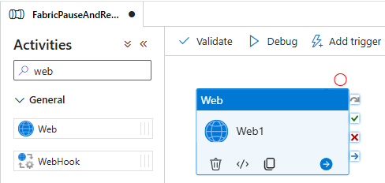

1. Under **Activities** type **web** in the search bar and drag the **Web** activity on to the canvas

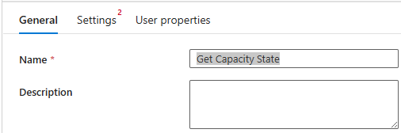

1. Change the **Name** to **Get Capacity State**
2. Click on the **Settings** tab

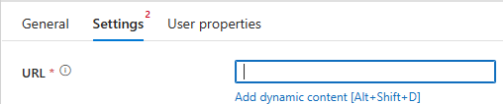

1. Click on **URL**, then select **Add dynamic content**

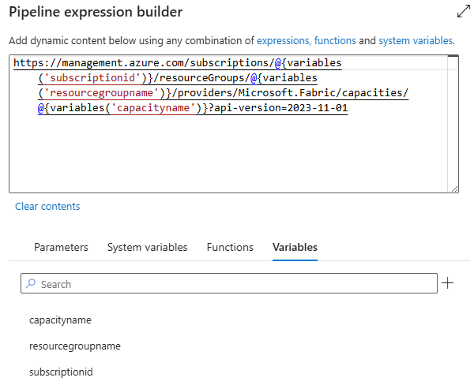

1. Copy the URL for **GET** from the API References section at the top of this document and paste it into the Pipeline expression builder
2. Add an @ symbol before each parameter, then click on the Variable tab and select the appropriate variable to replace the parameter
3. Click **OK**

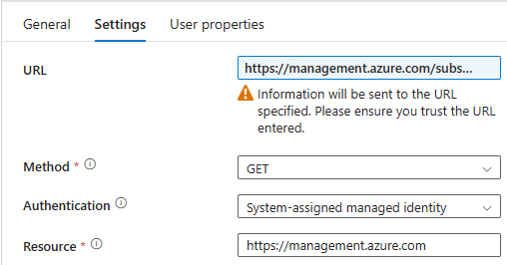

1. Select **Get** as the **Method**
2. Select **System-assigned manage identity** as the **Authentication**
3. Enter **https://management.azure.com** as the **Resource**

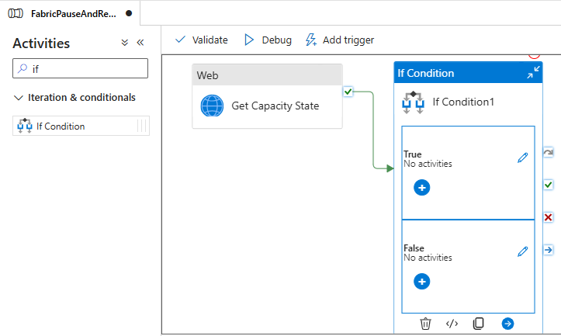

1. Under **Activities**, enter **if** in the search bar and drag and drop the **If Condition** activity on to the canvas
2. Drag the **green checkmark** from the **Web** activity to the **If Condition** activity

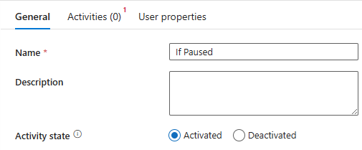

1. Click on the **General** tab of the **If Condition1**
2. Rename it from **If Condition1** to **If Paused**

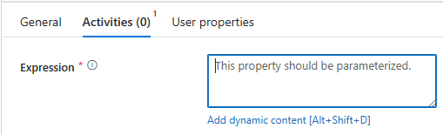

1. Click the **Activities** tab
2. Click inside the **Expression** box and select **Add dynamic content**

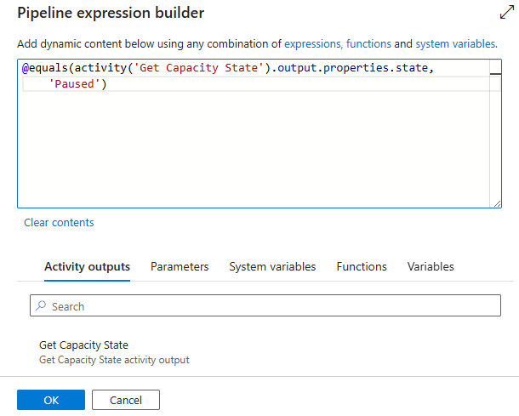

1. Add the following code to the Pipeline expression builder

@equals(activity('Get Capacity State').output.properties.state, 'Paused')

1. Click **OK**

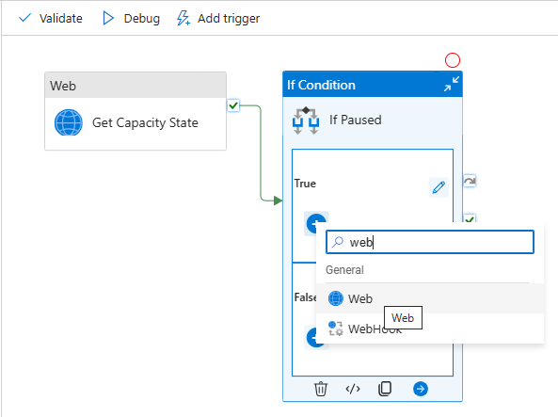

1. Click the **+** inside the **True** box of the **If Paused** activity, and add a **Web** activity
2. Click the **+** inside the **False** box of the **If Paused** activity, and add a **Web** activity

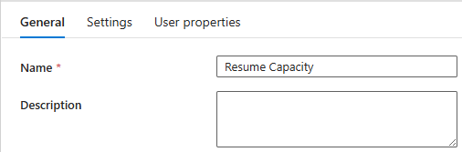

1. Click on **Web1** in the **True** box
2. On the General tab, rename it to **Resume Capacity**

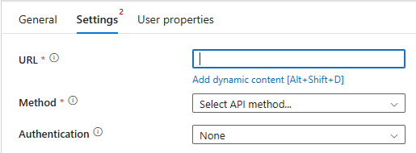

1. Click on the **Settings** tab
2. Click inside the **URL** box and click on **Add dynamic content**

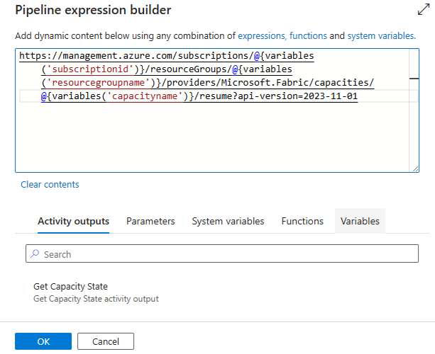

1. Paste the following into the **Pipeline expression builder**

https://management.azure.com/subscriptions/@{variables('subscriptionid')}/resourceGroups/@{variables('resourcegroupname')}/providers/Microsoft.Fabric/capacities/@{variables('capacityname')}/resume?api-version=2023-11-01

1. Click **OK**

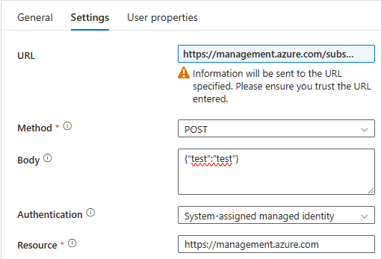

1. Select **POST** as the **Method**
2. Enter **{“test”:”test”}** as the **Body**

*FYI: Body is irrelevant for Resume, but must have something in it*

1. Select **System-assigned manage identity** as the **Authentication**
2. Enter **https://management.azure.com** as the **Resource**

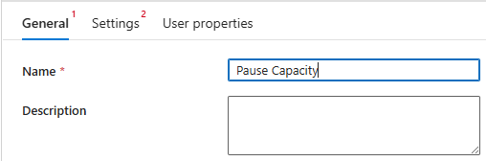

1. Click on **Web2** in the **True** box
2. On the General tab, rename it to **Pause Capacity**

1. Click on the **Settings** tab
2. Click inside the **URL** box and click on **Add dynamic content**

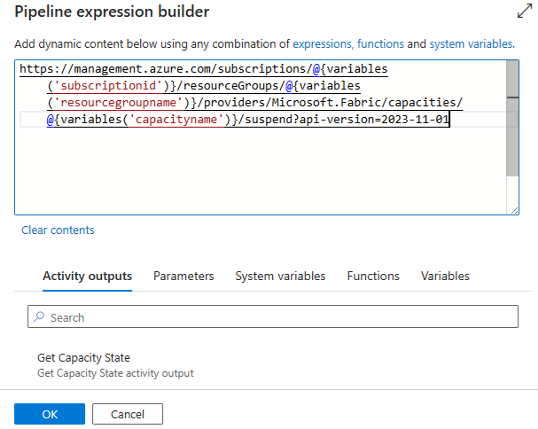

1. Paste the following into the **Pipeline expression builder**

https://management.azure.com/subscriptions/@{variables('subscriptionid')}/resourceGroups/@{variables('resourcegroupname')}/providers/Microsoft.Fabric/capacities/@{variables('capacityname')}/suspend?api-version=2023-11-01

1. Click **OK**

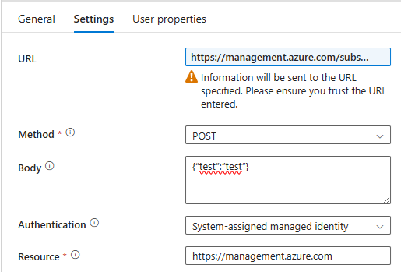

1. Select **POST** as the **Method**
2. Enter **{“test”:”test”}** as the **Body**

*FYI: Body is irrelevant for Suspend, but must have something in it*

1. Select **System-assigned manage identity** as the **Authentication**
2. Enter **https://management.azure.com** as the **Resource**

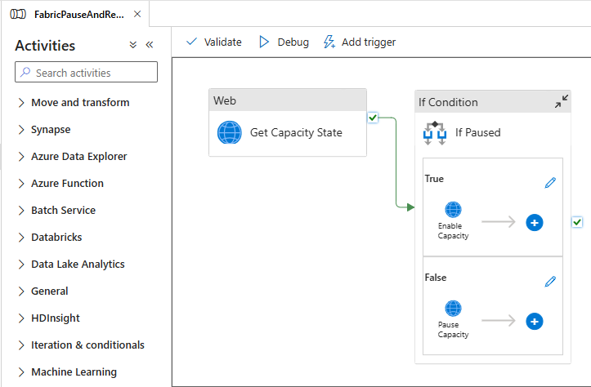

1. Pipeline should look like this



1. Click **Publish all** at the top

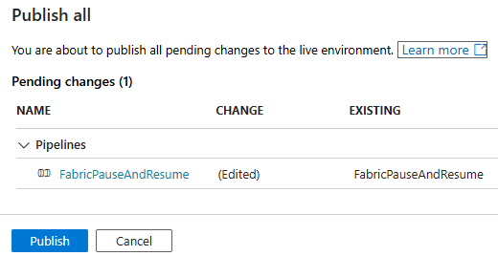

1. Click **Publish**



1. Wait for the pipeline publishing to complete

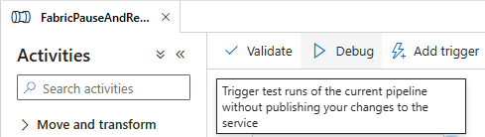

1. Click **Debug**

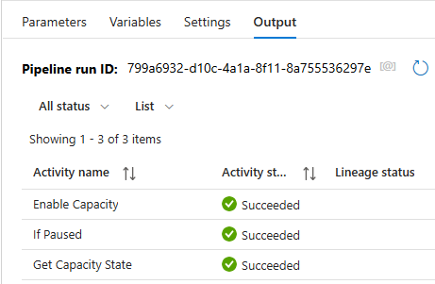

1. Once Succeeded, go and check that the Fabric Compute

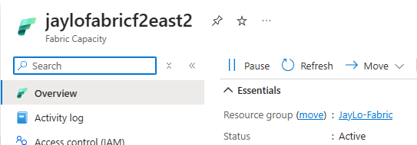

1. Status has been changed from **Paused** to **Active**

## **ADF Pipeline – Scale Compute**

1. In **Azure Data Factory (ADF)**

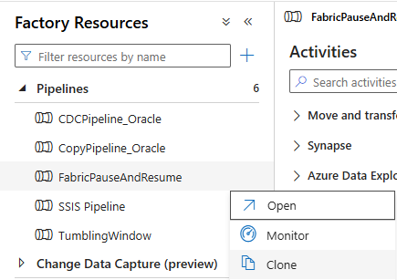

1. Click on **…** just to the right of the **FabricPauseAndResume** Pipeline you previously created, and select **Clone**

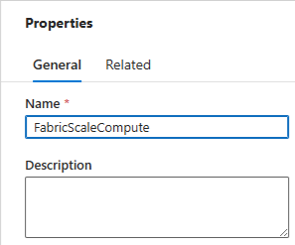

1. Rename the Pipeline to **FabricScaleCompute**
2. Click a blank spot anywhere in the canvas

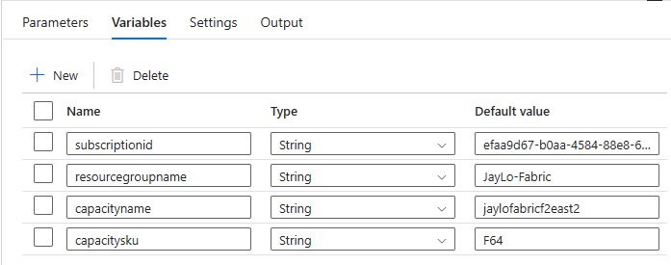

1. Click on the **Variables** tab and create a new parameter call **capacitysku**
2. Set the **Default value** to **F64**

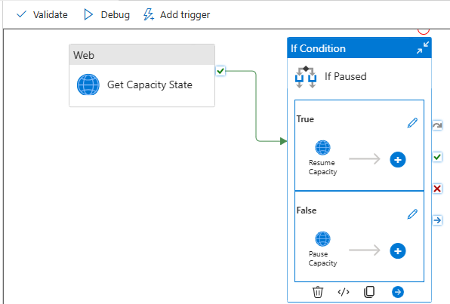

1. Click on the **If Paused** activity and inside the **True** box, click on the **pencil**

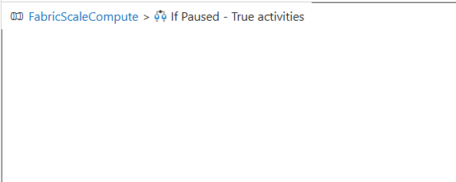

1. Delete the **Resume Capacity** Web activity

*FYI: If compute is paused, then it cannot be scaled*

1. Click on the **FabricScaleCompute** breadcrumb to get back to the main pipeline

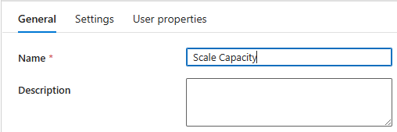

1. Click on the **Pause Capacity** activity under the **False** box of the **If Paused** activity
2. On the **General** tab, change the Name from **Pause Capacity** to **Scale Capacity**

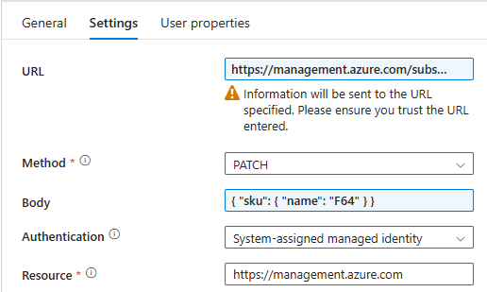

1. Click on the **Settings** tab

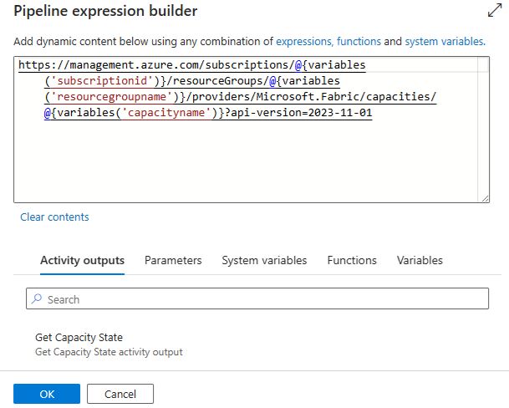

1. Click the **URL** box and paste the following into the Pipeline expression

**https://management.azure.com/subscriptions/@{variables('subscriptionid')}/resourceGroups/@{variables('resourcegroupname')}/providers/Microsoft.Fabric/capacities/@{variables('capacityname')}?api-version=2023-11-01**

1. Change **Method** to **PATCH**

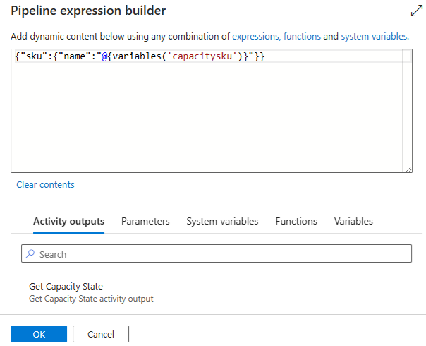

1. Click on the **Body** box and paste the following into the Pipeline expression builder

**{"sku":{"name":"@{variables('capacitysku')}"}}**

*FYI: Body is required for Patch, but should have the sku defined*

1. Click **OK**
2. Leave **System-assigned manage identity** as the **Authentication**
3. Leave **https://management.azure.com** as the **Resource**

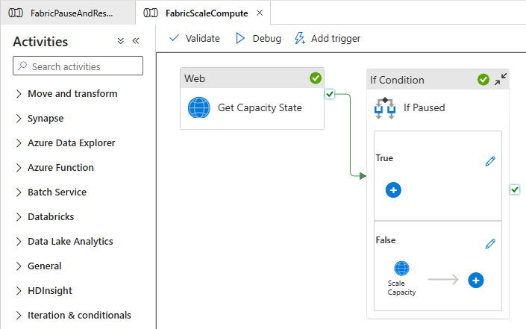

1. Pipeline should look like this



1. Click **Publish all** at the top

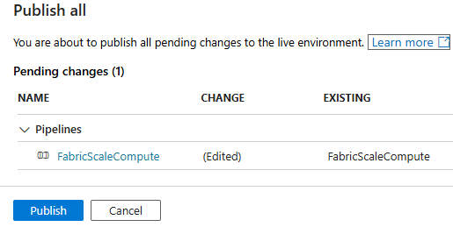

1. Click **Publish**

1. Wait for the pipeline publishing to complete

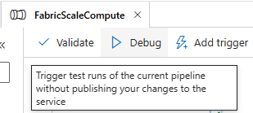

1. Click **Debug**

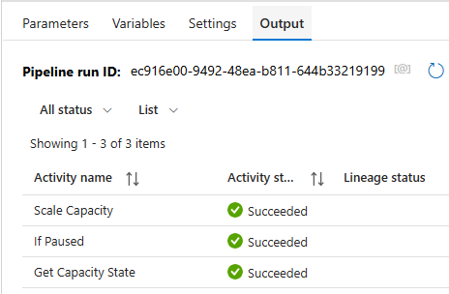

1. Once Succeeded, go and check that the Fabric Compute



1. Size has been changed from **F2** to **F64**

# **Fabric**

## **Create a Service Principal**

* + - 1. Log into the Azure Portal

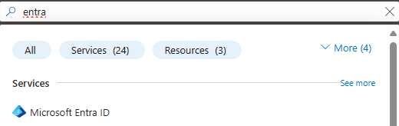

* + - 1. Go to **Microsoft Entra ID** by either typing it in the search bar and selecting **Microsoft Entra ID** or by clicking on it in the left-hand menu

* + - 1. Click on **App registration** under **Manage**
      2. Click **+ New registration**

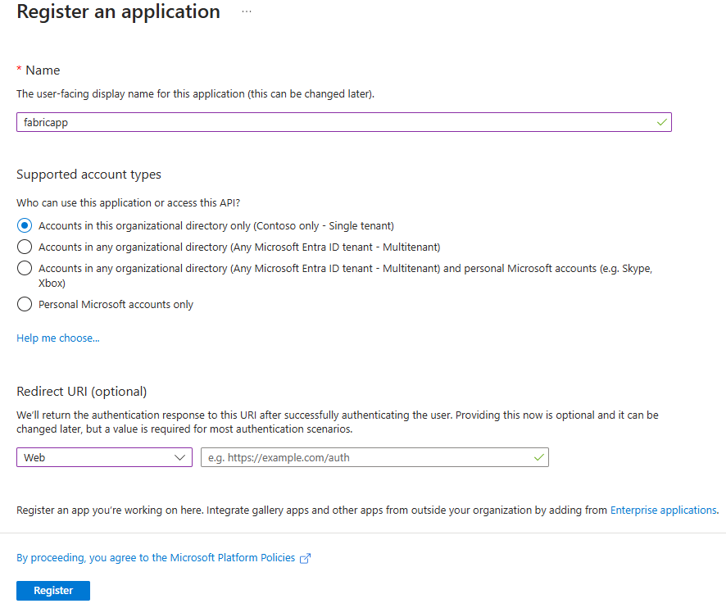

* + - 1. Give the application a **Name**
      2. Leave **Supported account types** as is
      3. Select **Web** as the **Select a platform**
      4. Leave **URL** blank
      5. Click **Register**

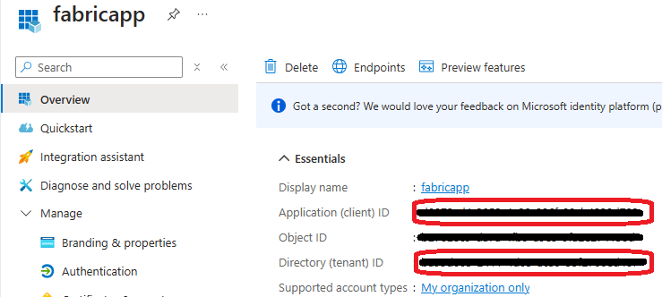

* + - 1. Mark down the Application (client) ID and Directory (tenant) ID

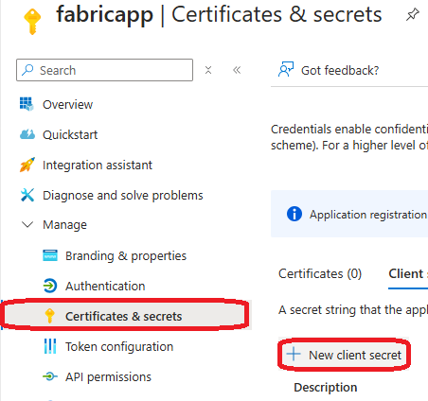

* + - 1. Click on **Certificates & secrets**, then click on **+ New client secret**

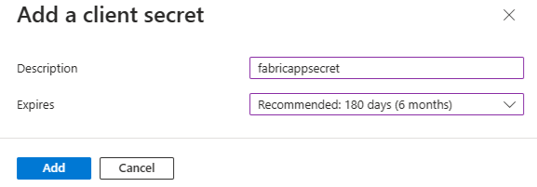

* + - 1. Enter a **Description** for the secret
      2. Select an **Expires** time

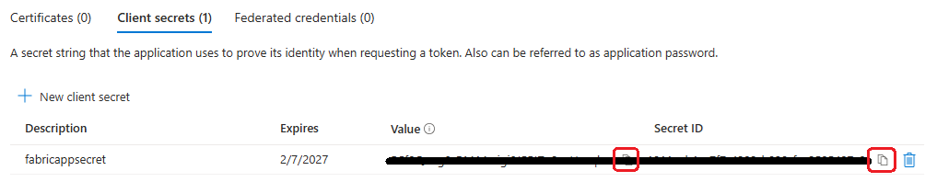

* + - 1. Copy and save both the **Value** and **Secret ID** for the new key
      2. In the Azure Portal, go to your Microsoft Fabric Compute

* + - 1. In the Azure Portal select one of your Fabric Capacities
      2. Click on **Access Control (IAM)**
      3. Click **+ Add**, then **Add role assignment**

* + - 1. Click on **Privileged administrator roles**
      2. Click **Contributor**
      3. Click **Next**

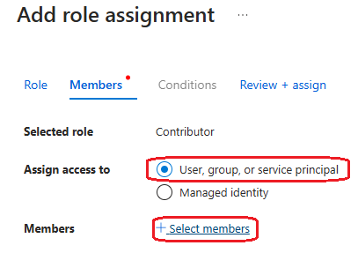

* + - 1. Select **User, group, or service principal** then **+ Select Members**

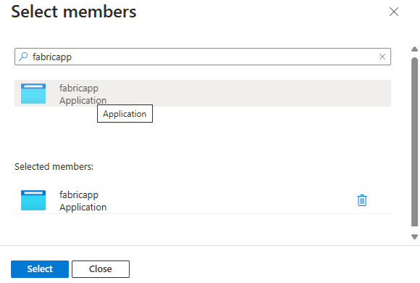

* + - 1. Enter your app name
      2. Click on your **Application** to select it



* + - 1. Click **Select**



* + - 1. Click **Review + assign** twice
      2. Repeat for all other capacities

## **Fabric Pipeline – Pause and Resume**

*FYI: This will only succeed on Fabric Computes that are outside of the one attached to the Workspace where this pipeline runs*

* + - 1. Log into the Fabric portal
      2. Select an appropriate Workspace

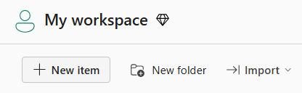

* + - 1. Within the Workspace, click **+ New item** on the top menu

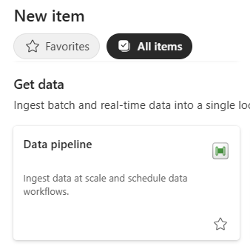

* + - 1. Either filter or scroll to find the **Data pipeline** item and click on it

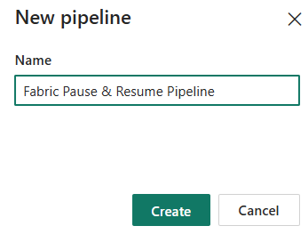

* + - 1. Enter a **Name** for the pipeline and then click **Create**
      2. Right-click anywhere in the canvas

* + - 1. Click on the **Variables** tab and click **+ New** three times
      2. Enter the name of the first variable as **subscriptionid**
      3. Copy and paste the **Subscription ID** from the Azure Portal to the **Default value**
      4. Enter the name of the second variable as **resourcegroupname**
      5. Copy and paste the **Resource Group Name** from the Azure Portal to the **Default value**
      6. Enter the name of the third variable as **capacityname**
      7. Copy and paste the **Fabric** **Capacity Name** from the Azure Portal to the **Default value**

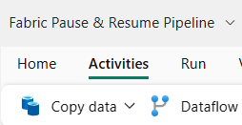

* + - 1. Click on **Activities** in the menu

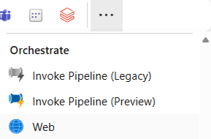

* + - 1. Select **Web** or **…** and find **Web** under **Orchestrate**

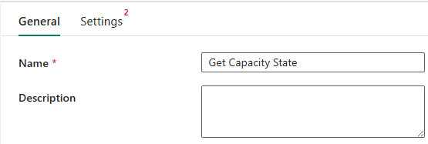

* + - 1. Change the **Name** to **Get Capacity State**
      2. Click on the **Settings** tab

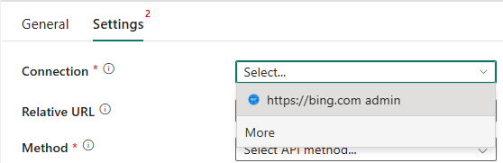

* + - 1. Click on the **Select** next to **Connection**, then select **More**



* + - 1. Click on **Web v2**

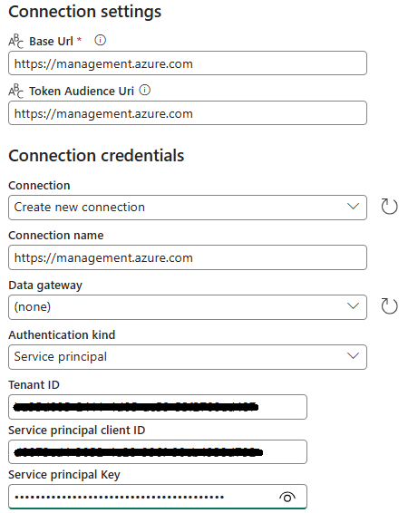

* + - 1. Enter **https://management.azure.com** for the **Base URL**
      2. Enter **https://management.azure.com** for the **token audience URI**
      3. Leave **Data gateway** as **(none)**
      4. Change the Connection name to **https://management.azure.com**
      5. Select **Service principal** for **Authentication kind**
      6. Paste the **Directory (tenant) ID** you save earlier into the **Tenant ID**
      7. Paste the **Application (client) ID** you save earlier into the **Service principal client ID**
      8. Paste the **Secret Value** you save earlier into the **Service principal Key**
      9. Click **Connect**

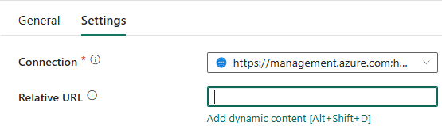

* + - 1. Click on **Relative URL**, then select **Add dynamic content**

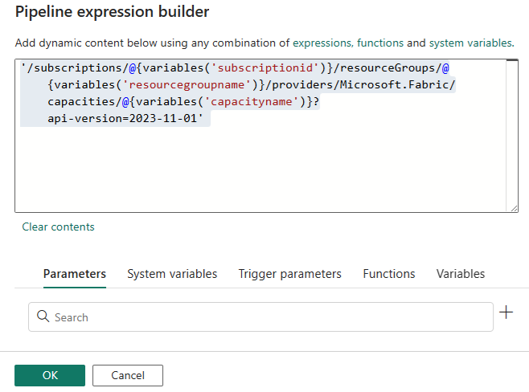

* + - 1. Paste the following code into the Pipeline expression builder

**@concat('/subscriptions/',variables('subscriptionid'),'/resourceGroups/',variables('resourcegroupname'),'/providers/Microsoft.Fabric/capacities/',variables('capacityname'),'?api-version=2022-07-01-preview')**

* + - 1. Click **OK**

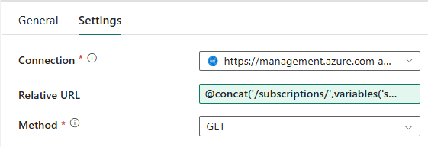

* + - 1. Select **Get** as the **Method**

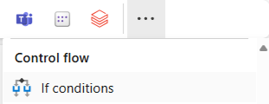

* + - 1. Click on **Activities** in the menu
      2. Select **If conditions** or **…** and find **If conditions** under **Control flow**

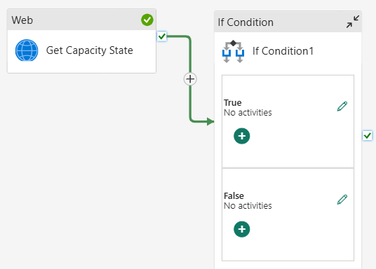

* + - 1. Drag the **green checkmark** from the **Web** activity to the **If Condition** activity

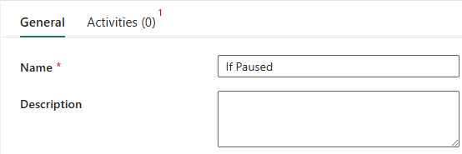

* + - 1. Click on the **General** tab of the **If Condition1**
      2. Rename it from **If Condition1** to **If Paused**

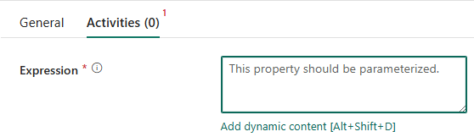

* + - 1. Click the **Activities** tab
      2. Click inside the **Expression** box and select **Add dynamic content**

* + - 1. Add the following code to the Pipeline expression builder

**@equals(activity('Get Capacity State').output.properties.state, 'Paused')**

* + - 1. Click **OK**

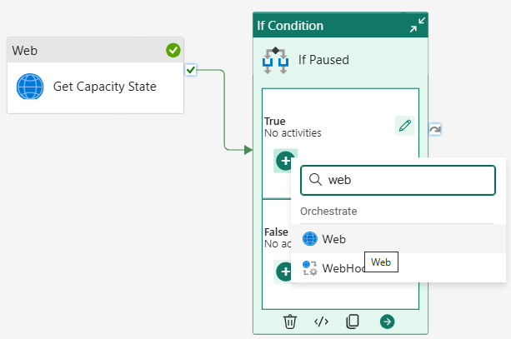

* + - 1. Click the **+** inside the **True** box of the **If Paused** activity, and add a **Web** activity
      2. Click the **+** inside the **False** box of the **If Paused** activity, and add a **Web** activity

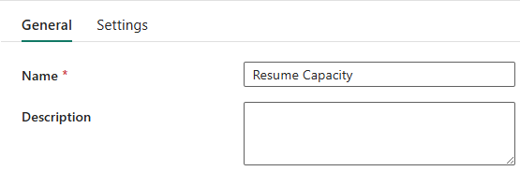

* + - 1. Click on **Web1** in the **True** box
      2. On the General tab, rename it to **Resume Capacity**

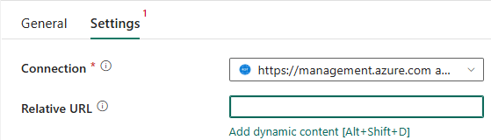

* + - 1. Click on the **Settings** tab
      2. Select the same connection you created for the Get Capacity State
      3. Click inside the **Relative URL** box and click on **Add dynamic content**

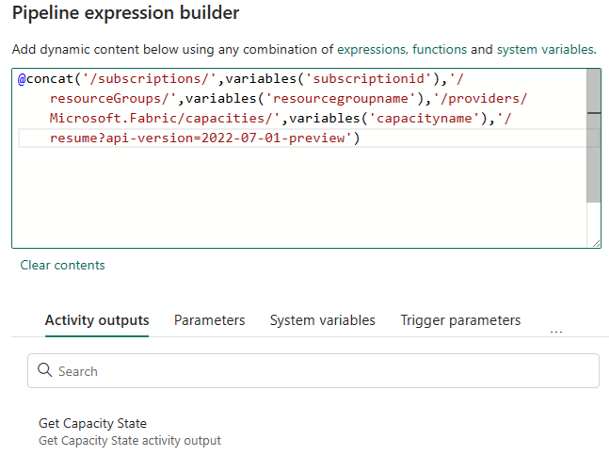

* + - 1. Paste the following into the **Pipeline expression builder**

**@concat('/subscriptions/',variables('subscriptionid'),'/resourceGroups/',variables('resourcegroupname'),'/providers/Microsoft.Fabric/capacities/',variables('capacityname'),'/resume?api-version=2022-07-01-preview')**

* + - 1. Click **OK**

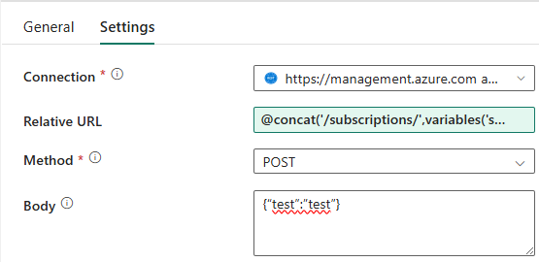

* + - 1. Select **POST** as the **Method**
      2. Enter **{“test”:”test”}** as the **Body**

*FYI: Body is irrelevant for Resume, but must have something in it*

* + - 1. Click on **Web2** in the **True** box
      2. On the General tab, rename it to **Pause Capacity**

* + - 1. Click on the **Settings** tab
      2. Select the same connection you created for the Get Capacity State
      3. Click inside the **Relative URL** box and click on **Add dynamic content**

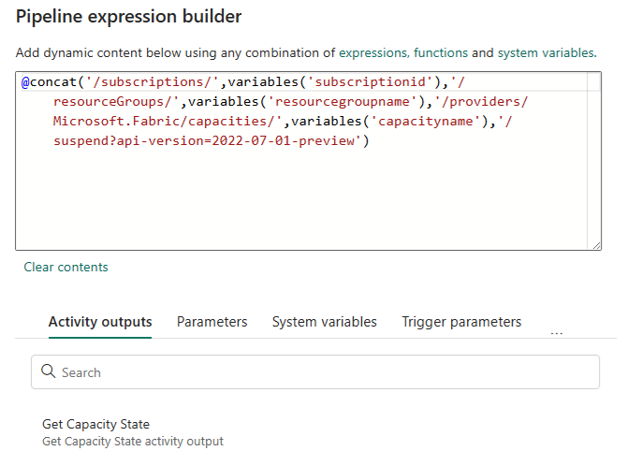

* + - 1. Paste the following into the **Pipeline expression builder**

**@concat('/subscriptions/',variables('subscriptionid'),'/resourceGroups/',variables('resourcegroupname'),'/providers/Microsoft.Fabric/capacities/',variables('capacityname'),'/suspend?api-version=2022-07-01-preview')**

* + - 1. Click **OK**

* + - 1. Select **POST** as the **Method**
      2. Enter **{“test”:”test”}** as the **Body**

*FYI: Body is irrelevant for Suspend, but must have something in it*

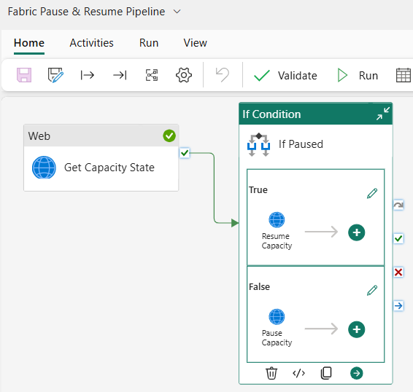

* + - 1. Pipeline should look like this
      2. Click **Save** on the **Home** Menu
      3. Click **Run** on the **Home** Menu

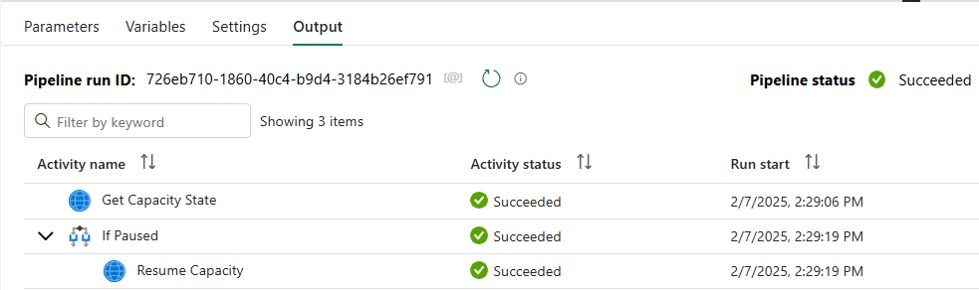

* + - 1. Once Succeeded, go and check that the Fabric Compute

* + - 1. Status has been changed from **Paused** to **Active**

## **Fabric Pipeline – Scale Compute**

1. In **Fabric**, open the Pipeline created previously

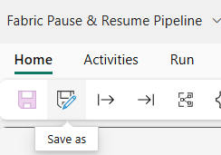

1. Click on the **Save as** icon on the Home menu

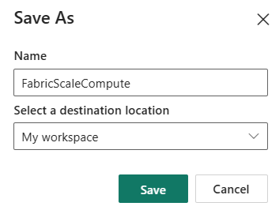

1. Change the Name of the new Pipeline to **FabricScaleCompute**
2. Select the appropriate **destination location**
3. Click **Save**
4. Click a blank spot anywhere in the canvas

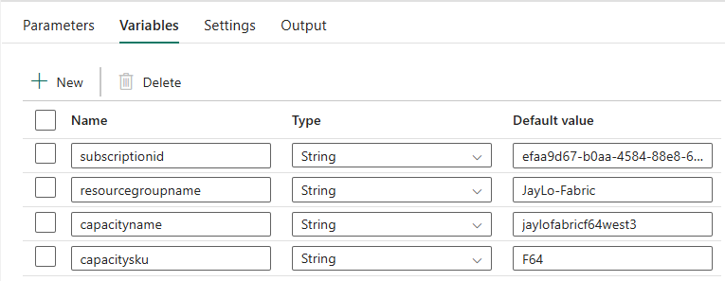

1. Click on the **Variables** tab and create a new parameter call **capacitysku**
2. Set the **Default value** to **F64**

1. Click on the **If Paused** activity and inside the **True** box, click on the **pencil**

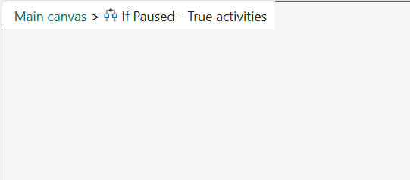

1. Delete the **Resume Capacity** Web activity

*FYI: If compute is paused, then it cannot be scaled*

1. Click on the **Main canvas** breadcrumb to get back to the main pipeline

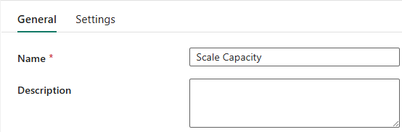

1. Click on the **Pause Capacity** activity under the **False** box of the **If Paused** activity
2. On the **General** tab, change the Name from **Pause Capacity** to **Scale Capacity**

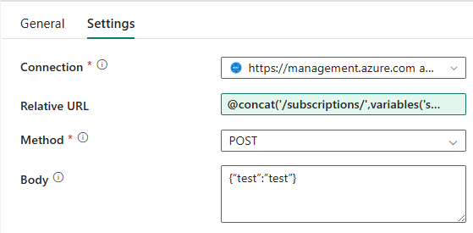

1. Click on the **Settings** tab
2. Leave Connection as is
3. Click on the Relative URL box to change the expression

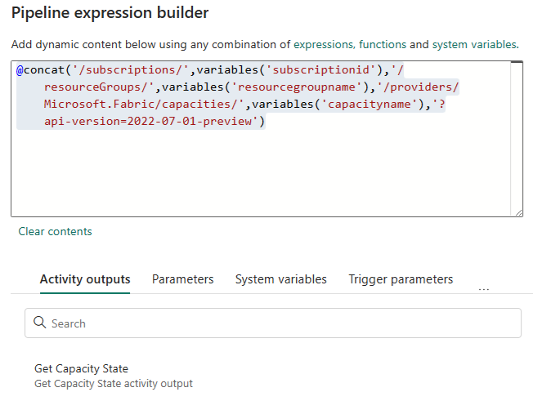

1. Paste the following into the Pipeline expression

**@concat('/subscriptions/',variables('subscriptionid'),'/resourceGroups/',variables('resourcegroupname'),'/providers/Microsoft.Fabric/capacities/',variables('capacityname'),'?api-version=2022-07-01-preview')**

1. Click **OK**

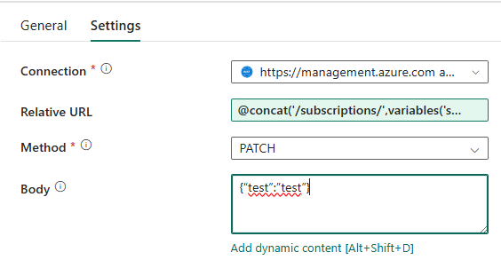

1. Change **Method** to **PATCH**
2. Click on the **Body** box and select **Add dynamic content**

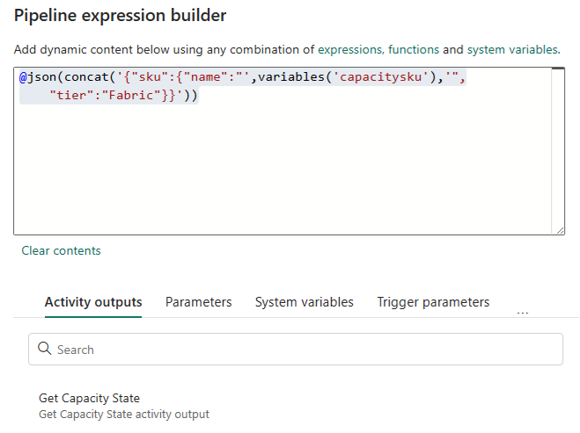

1. Paste the following into the Pipeline expression builder

**@json(concat('{"sku":{"name":"',variables('capacitysku'),'","tier":"Fabric"}}'))**

*FYI: Body is required for Patch, but should have the sku defined*

1. Click **OK**

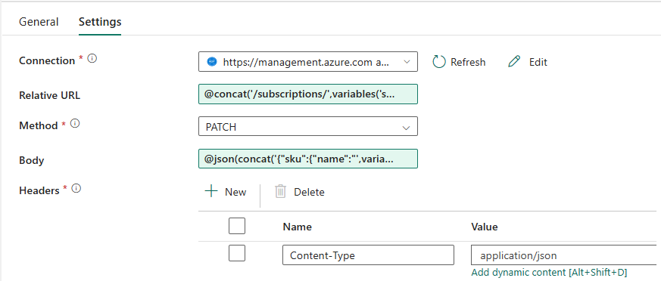

1. Click the **+ New** next to **Headers** to add a new header
2. Enter **Content-Type** as the **Name**
3. Enter **application/json** as the **Value**

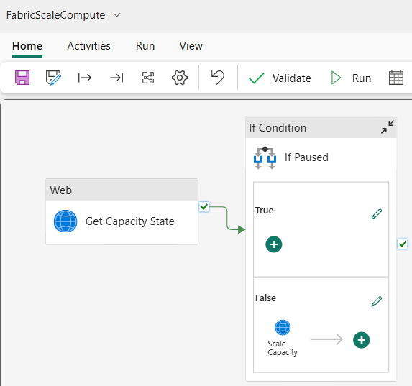

1. Pipeline should look like this
2. Click **Save** on the Home menu

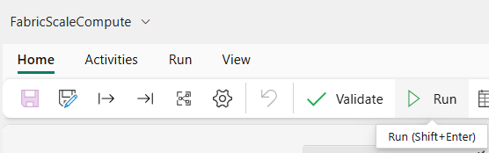

1. Click **Run**

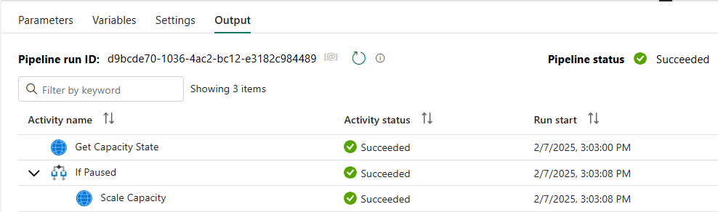

1. Once Succeeded, go and check that the Fabric Compute



1. Size has been changed from **F2** to **F64**

# **Other Methods (not documented)**

## **Azure Automation**

## **Azure CLI**

## **Azure Runbook**

## **PowerShell**

# **References**

* API - [Azure Microsoft Fabric REST API | Microsoft Learn](https://learn.microsoft.com/en-us/rest/api/microsoftfabric/?view=rest-microsoftfabric-2023-11-01)
* ADF Pipeline - [Automating Pause and Resume with ADF](https://www.bing.com/videos/riverview/relatedvideo?q=microsoft+fabric+pause+and+resume+pipeline&mid=3B2E68782BFD879065763B2E68782BFD87906576&FORM=VIRE)
* Power Apps - [Automate Pause/Resume Capacity with Azure Logic Apps](https://biinsight.com/microsoft-fabric-capacity-cost-management-part-2-automate-pause-resume-capacity-with-azure-logic-apps/)